Part A: Nmap Scanning

All commands executed | Explanation of every argument used
-sV (service version detection scan) | service/version detection on all 1000 default ports
-sT (TCP connect scan) | Full TCP Connect scan
-T2 (timing templates) | Slow scanning
-T3 | Balanced speed scanning
-T4 | Faster speed than T3
-T5 | Fastest scanning
-F (fast scan) | Fast scan, only covers Common ports
-A (Aggressive scan) | Aggressive scans, detects OS, version, scripts

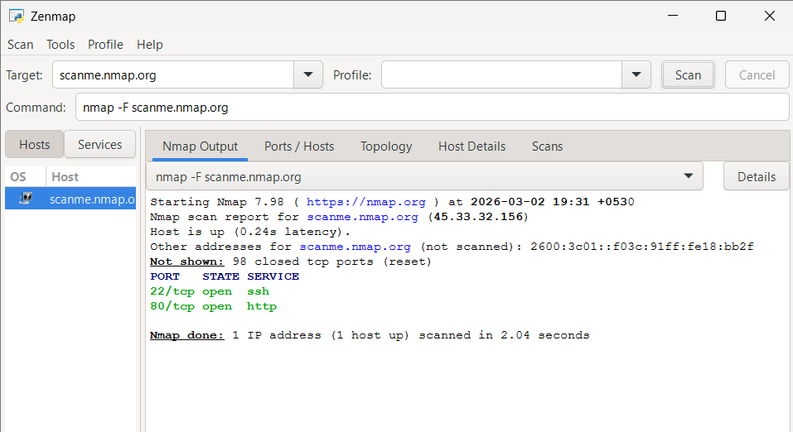
-F | Fast scan, only covers Common ports

-F has found only 2 open ports:
22/tcp – SSH
80/tcp – HTTP
Reveales the state of a port: open/close

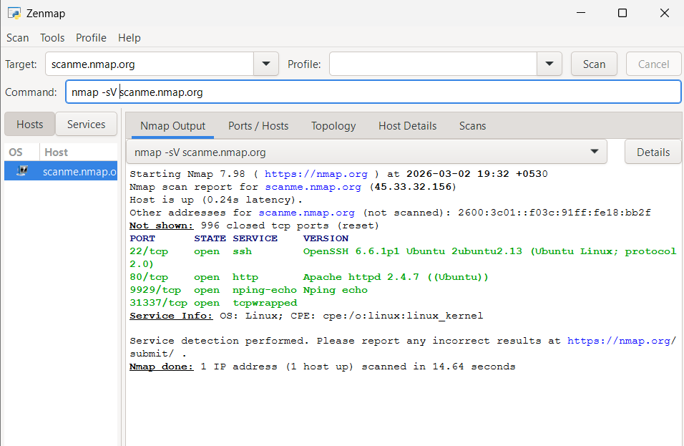
-sV | service/version detection on all 1000 default ports
-sV scan has revealed two new open ports:
9929/tcp nping-echo
31337/tcp tcpwrapped
Reveals service version of each service that’s being used.
Reveals service info: OS and CPE
PORT
22/tcp
80/tcp
9929/tcp
31337/tcp
STATE SERVICE
open ssh
open http
open nping-echo
open tcpwrapped
VERSION
OpenSSH 6.6.1p1 Ubuntu 2ubuntu2.13 (Ubuntu Linux; protocol 2.0)
Apache httpd 2.4.7 ((Ubuntu))
Nping echo
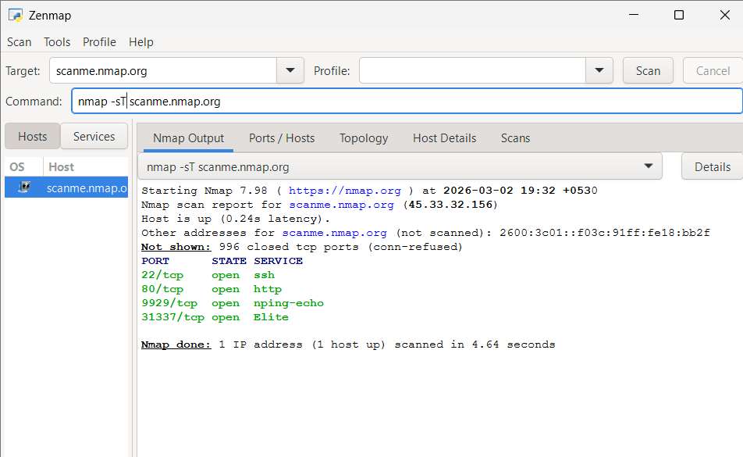
-sT reveals all 4 open ports, but does not show the service version neither does it give any service info.
Port 31337/tcp is displayed with its default name “Elite”
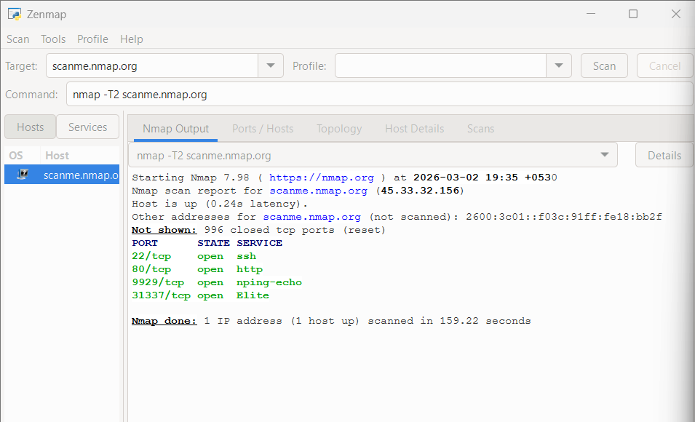
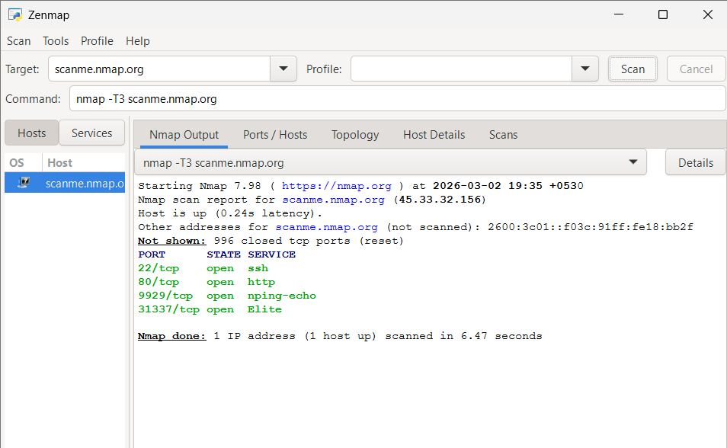

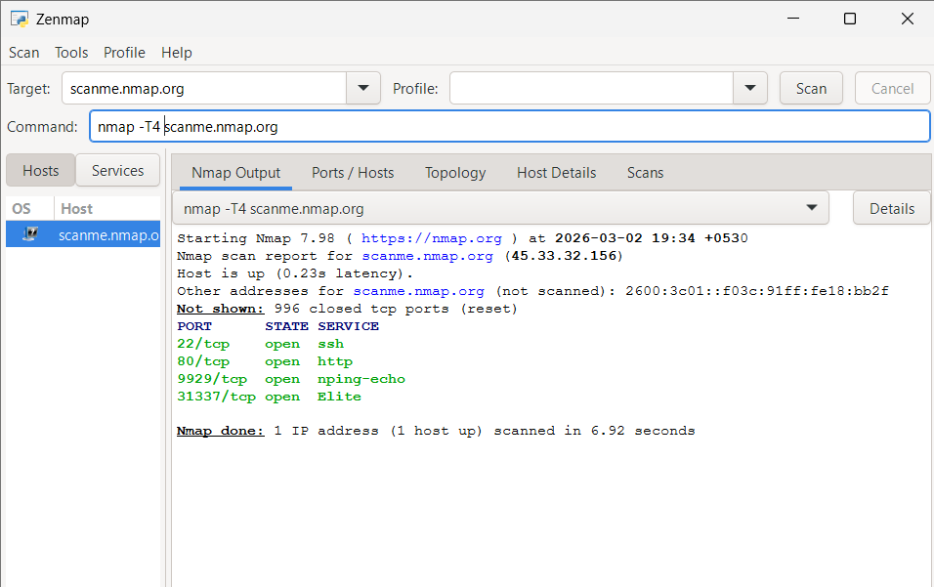
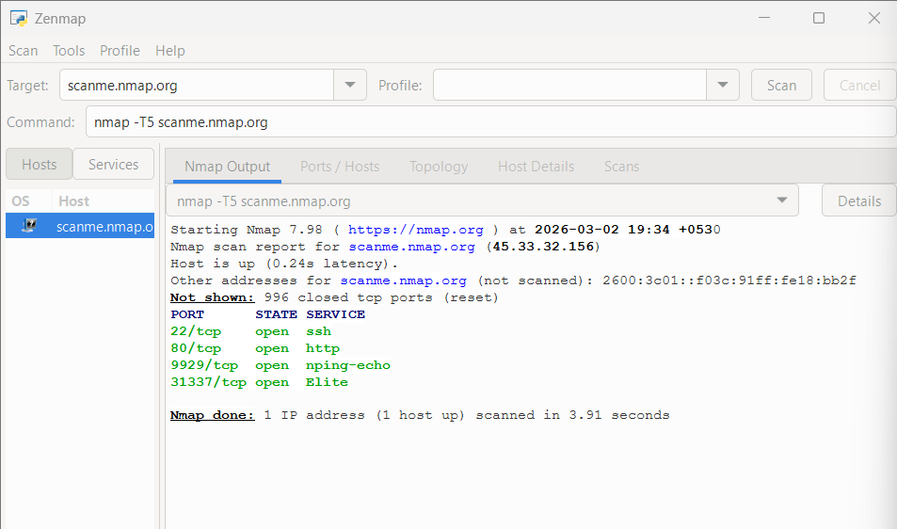

Template | Speed | Time Taken
T5 | fastest | 3.91s
T4 | Fast | 6.92s
3 | Balance | 6.47s
T2 | Slow | 159.22s

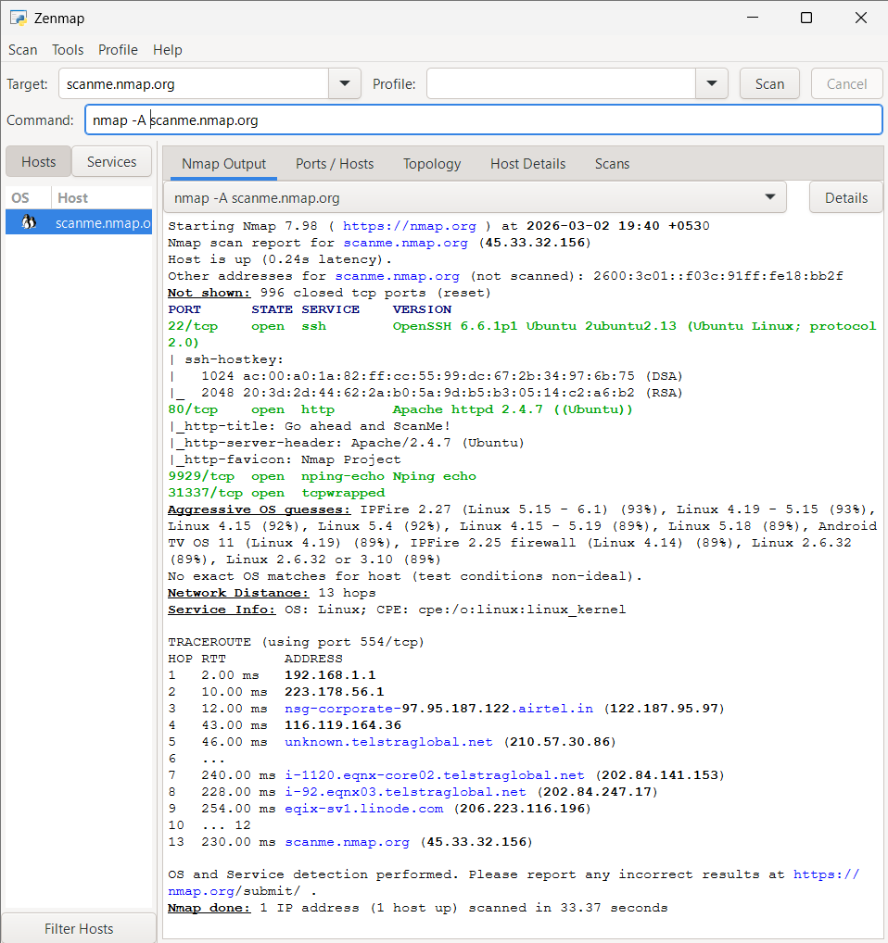
-A (Aggressive scan) is the most informative overall, even though it took 33.37s, it reveals:
Services & Versions
SSH Host Keys
HTTP Details (via NSE scripts)
OS Detection
Traceroute (13 hops)

Category | Finding
IP Address | 45.33.32.156
IPv6 | 2600:3c01::f03c:91ff:fe18:bb2f
OS | Ubuntu Linux (kernel 4.x–6.x)
Hosting | Linode cloud
Open Ports | 22, 80, 9929, 31337
SSH | OpenSSH 6.6.1p1
Web Server | Apache 2.4.7 (Ubuntu)
Special Ports | 9929 (Nping echo), 31337 (tcpwrapped)
Network Hops | 13 (routed via Airtel → Telstra → Linode)

Part B: VirusTotal Intelligence Gathering
•Reputation or detection results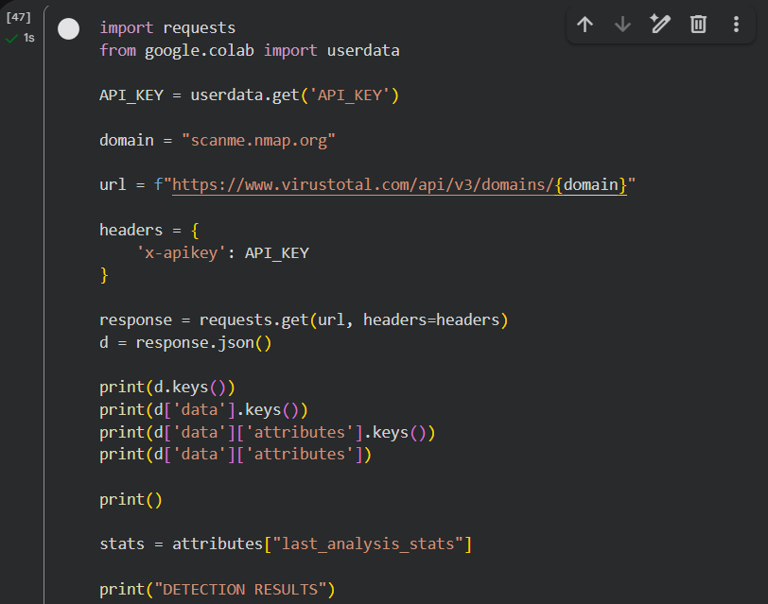
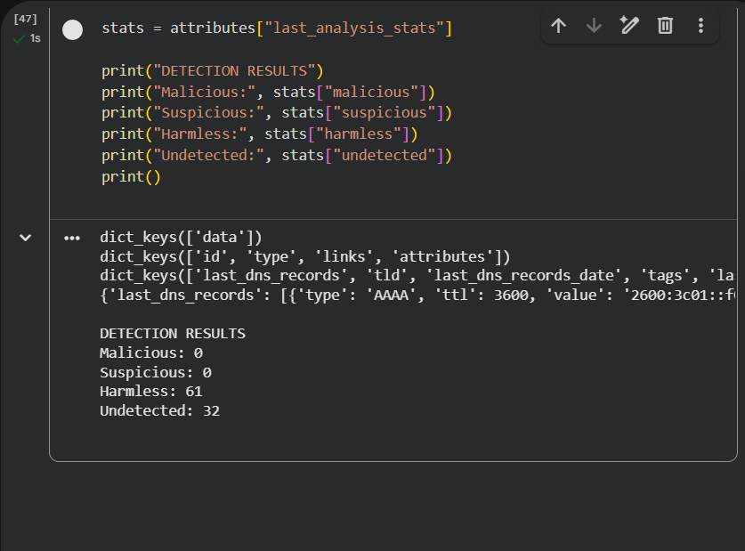
• Domain and IP intelligence
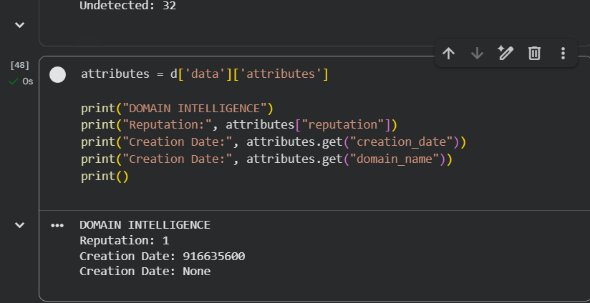

• Historical or contextual data
(only printed data including dates)
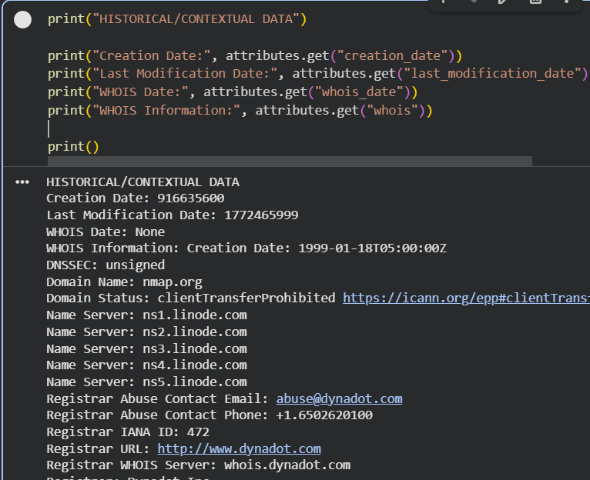

• Any security observations related to the target
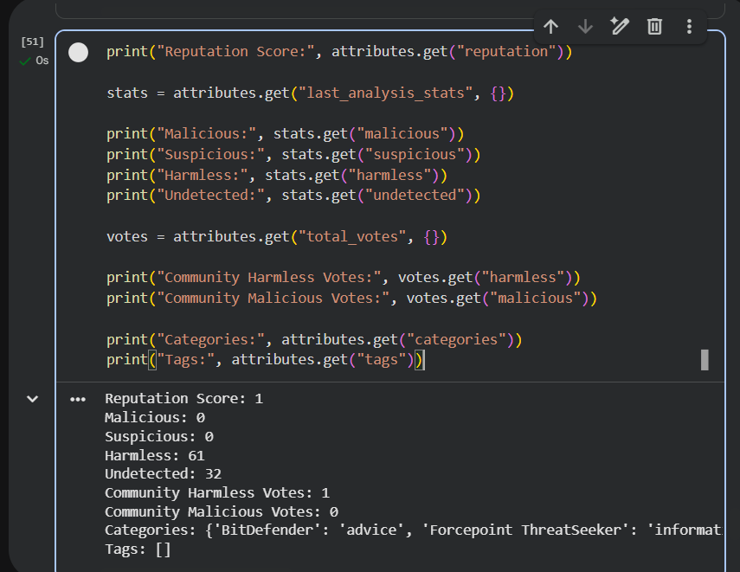

What VirusTotal is used for?
VirusTotal is used to check whether a domain, IP address, file, or URL has been flagged as malicious by security vendors. It collects data from multiple antivirus engines and threat intelligence sources and shows reputation scores, detection results, historical records, and related infrastructure information. Instead of scanning something myself, I can use VirusTotal to see if it has already been reported or associated with suspicious activity. It basically helps me understand the background and trust level of a target.

How passive intelligence differs from active scanning?
Passive intelligence means I am only looking at existing information that has already been collected. I am not directly interacting with the target system. When I use VirusTotal, I am simply reviewing stored data such as detection history, DNS records, and reputation scores.
Active scanning, on the other hand, involves directly interacting with the target. For example, when I use Nmap, I am sending packets to the server to identify open ports, services, and running versions. The target system can detect that it is being scanned. So, passive intelligence does not touch the target, while active scanning directly communicates with it.

How VirusTotal findings support or complement my Nmap results?
My Nmap scan showed the open ports and running services on the target system. This gave me technical information about what is exposed on the network. However, Nmap does not tell me whether the domain has a malicious history or bad reputation.
VirusTotal complements this by providing reputation scores, detection results from security vendors, and historical DNS data. While Nmap shows the current technical exposure, VirusTotal shows the historical and reputational background of the domain. Together, they provide a more complete security assessment by combining real-time scanning results with threat intelligence data.

meaning of each major port so far:
Port 22 - SSH (Secure Shell)
Secure remote login and command-line access to the server
OpenSSH 6.6.1p1 — Port 22
This version was released in 2014 and is over a decade old. Known risks include:
- CVE-2016-6210 — User enumeration vulnerability allowing attackers to determine valid usernames through timing differences in authentication responses
- CVE-2016-0777 — Information leak via the roaming feature that could expose private keys in memory
- Brute-force exposure — SSH exposed directly to the internet with no observed rate-limiting makes it a prime target for automated credential stuffing attacks
- Weak cipher support — Older OpenSSH versions negotiate legacy/weak ciphers and MAC algorithms that modern hardening guides explicitly disable
Port 80 - HTTP
Serves unencrypted web pages to browsers
Apache httpd 2.4.7 — Port 80
Released in 2013, this is a significantly outdated web server version. Known risks include:
- CVE-2017-7679 — Buffer overflow in mod_mime that could lead to remote code execution
- CVE-2017-9798 — "Optionsbleed" — memory leak via HTTP OPTIONS method exposing sensitive server memory contents
- CVE-2014-0226 — Race condition in mod_status enabling heap corruption
- No HTTPS/TLS — All data transmitted in plaintext, exposing any credentials, session tokens, or sensitive content to MITM attacks
- Server header disclosure — Apache/2.4.7 (Ubuntu) is openly advertised, giving attackers a precise target for version-specific exploits
Port 9929 - Nping Echo
Nmap's own network packet generation tool used for connectivity testing
- Traffic amplification — Can be abused to reflect and amplify network traffic toward a third-party victim
- Network mapping assistance — Exposes internal network timing and routing behaviour to any external party
- Unnecessary attack surface — A service with no business justification being publicly accessible violates the principle of least privilege
Port 31337 tcpwrapped
Port is open but the service dropped the connection before identifying itself
- Hidden service risk — The deliberate withholding of a banner prevents identification, making it impossible to assess what is actually running without deeper investigation
- Potential backdoor indicator — In any non-test environment, an unidentified service on this culturally significant port would strongly suggest a backdoor or unauthorised remote access tool
- No accountability — Since the service cannot be identified passively, there is no way to determine its patch status, configuration, or exposure level without active probing

What I Learned..

Through this exercise, I learned how to use Nmap to actively scan a target and read the results - things like open ports, running services, software versions, OS details, and how traffic routes across the internet. I explored how different flags like -F, -sV, -sT, and -A each serve a different purpose depending on whether I need speed, detail, or stealth. I then learned how VirusTotal works alongside active scanning by giving me passive intelligence. Overall, this gave me a solid foundation in the reconnaissance phase of ethical hacking - knowing how to combine active and passive techniques to build a complete picture of a target before going any further.

